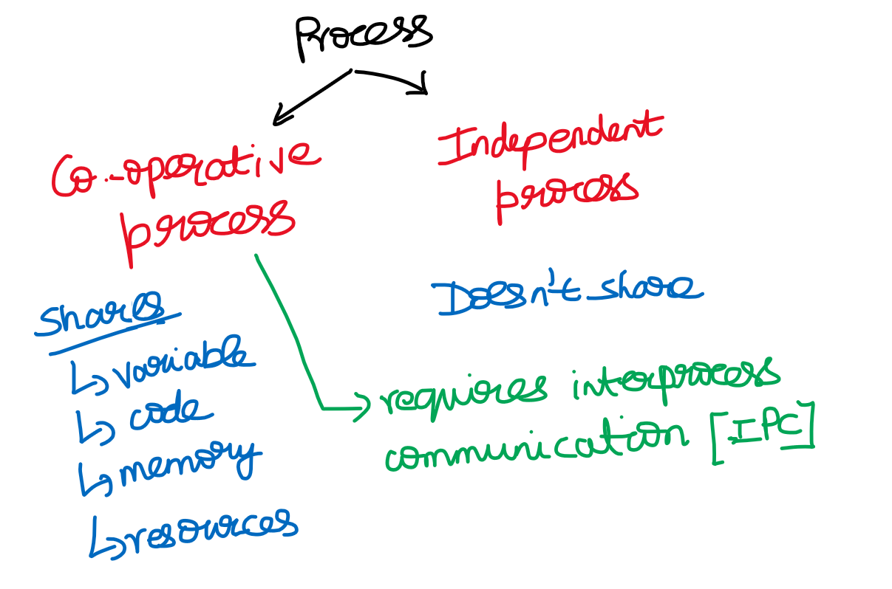

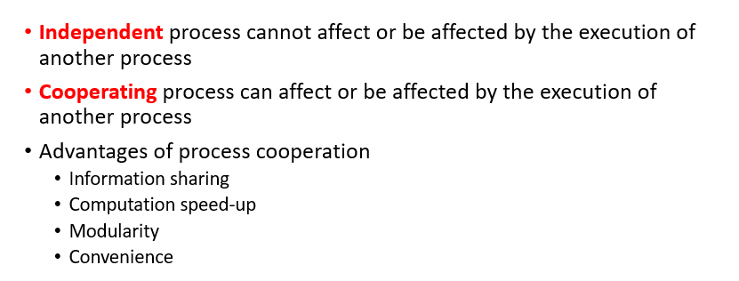

***unbounded-buffer*** places no practical limit on the size of the buffer

***bounded-buffer*** assumes that there is a fixed buffer size

**Producer-Consumer Problem**

count 🡪 how many items are there in buffer  
in 🡪 will point out the next empty slot(producer)  
out 🡪 will point to the next slot where there is a item to be produced(consumer)

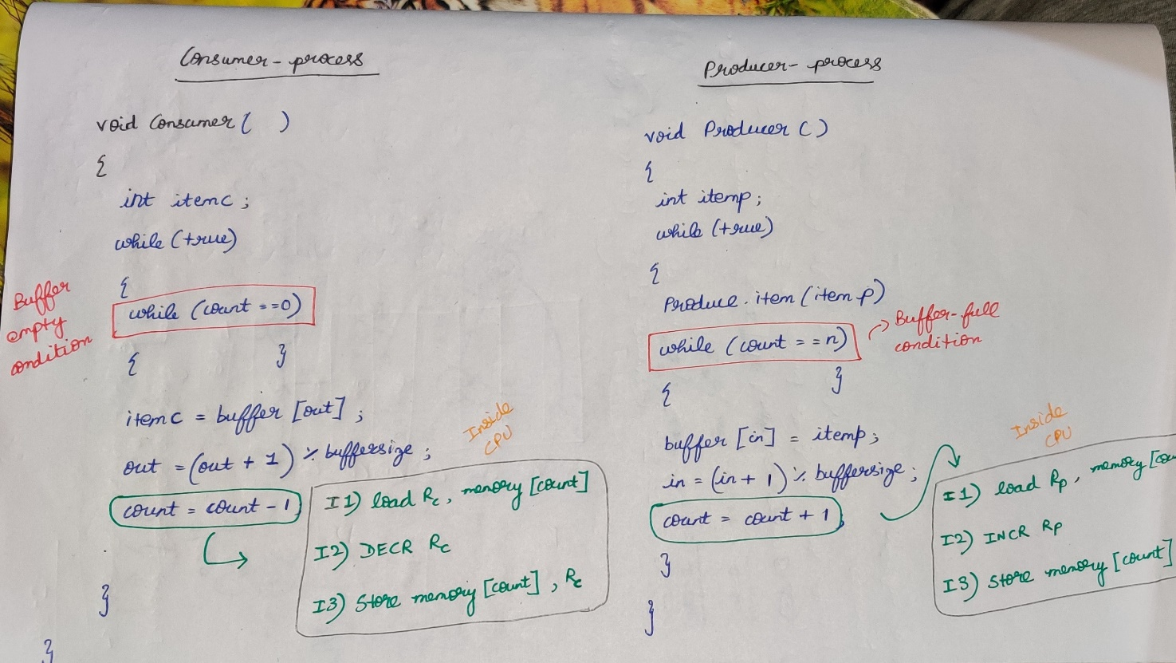



Case-1: Adding 1 item into the buffer and consuming it.

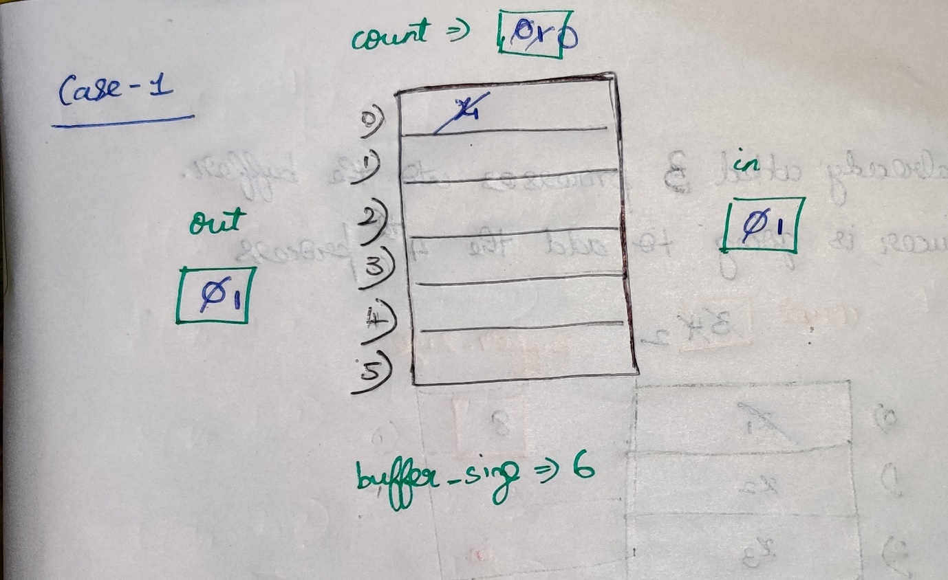

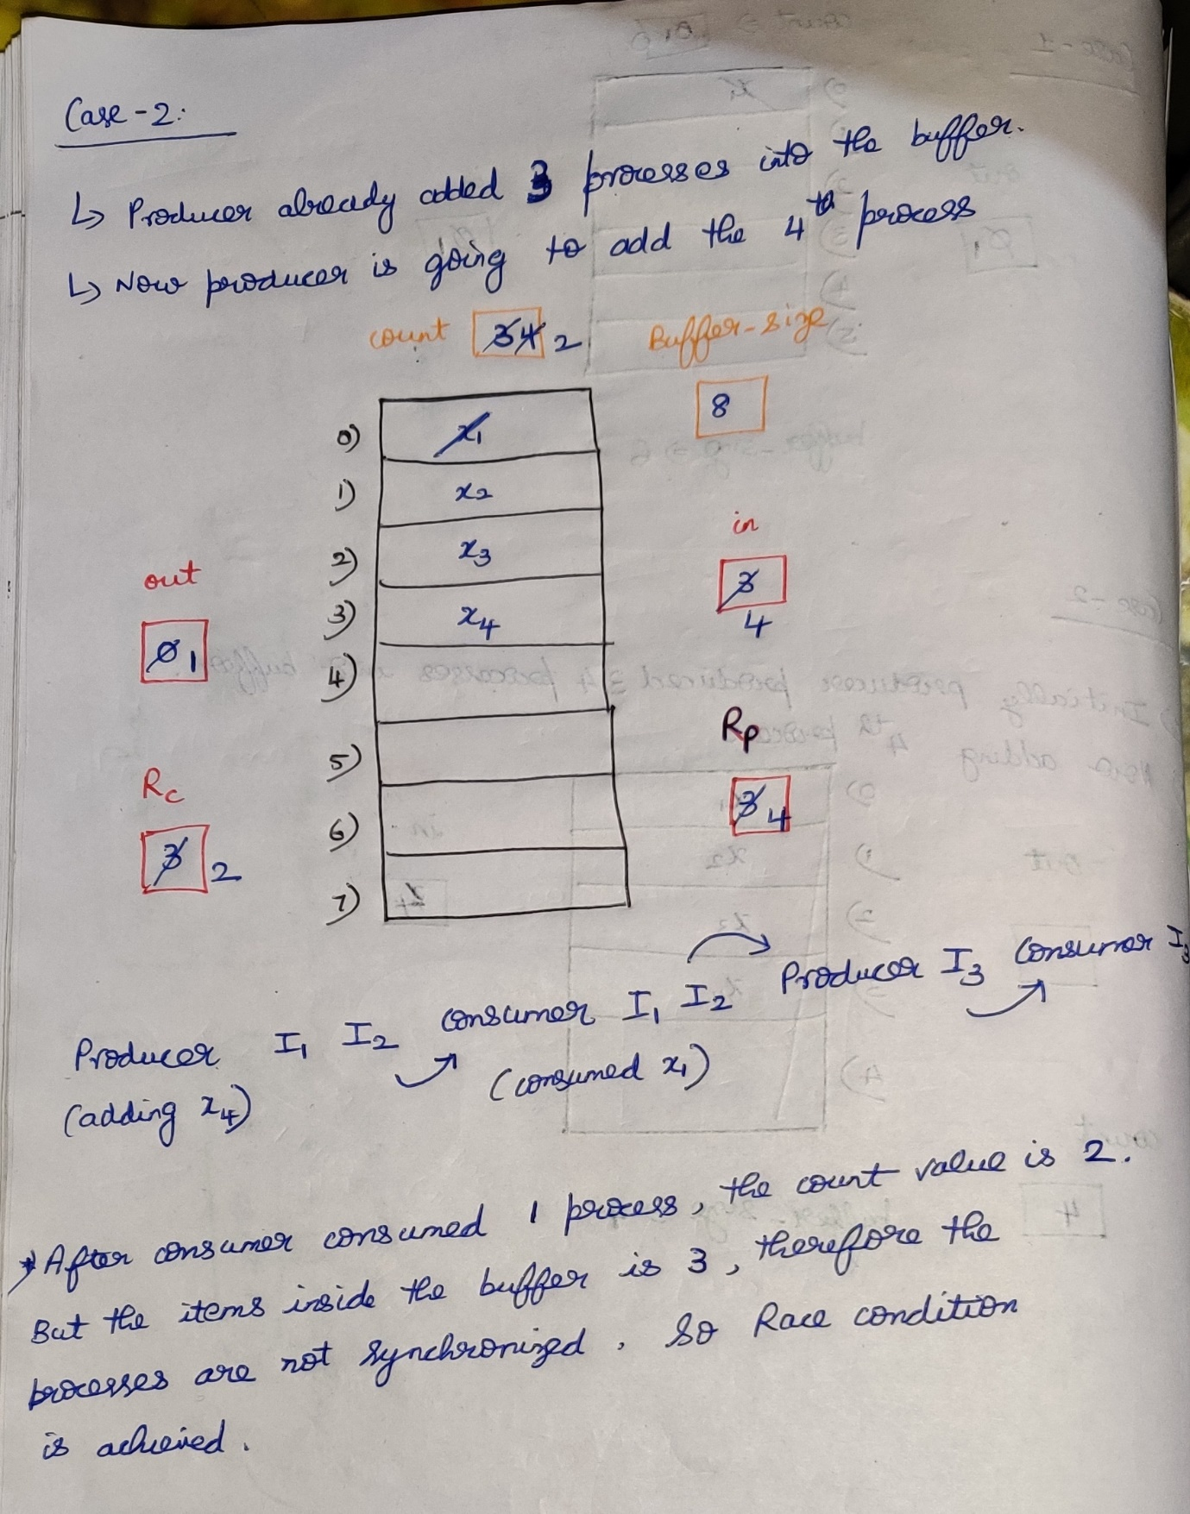



**Printer Spooler Problem**

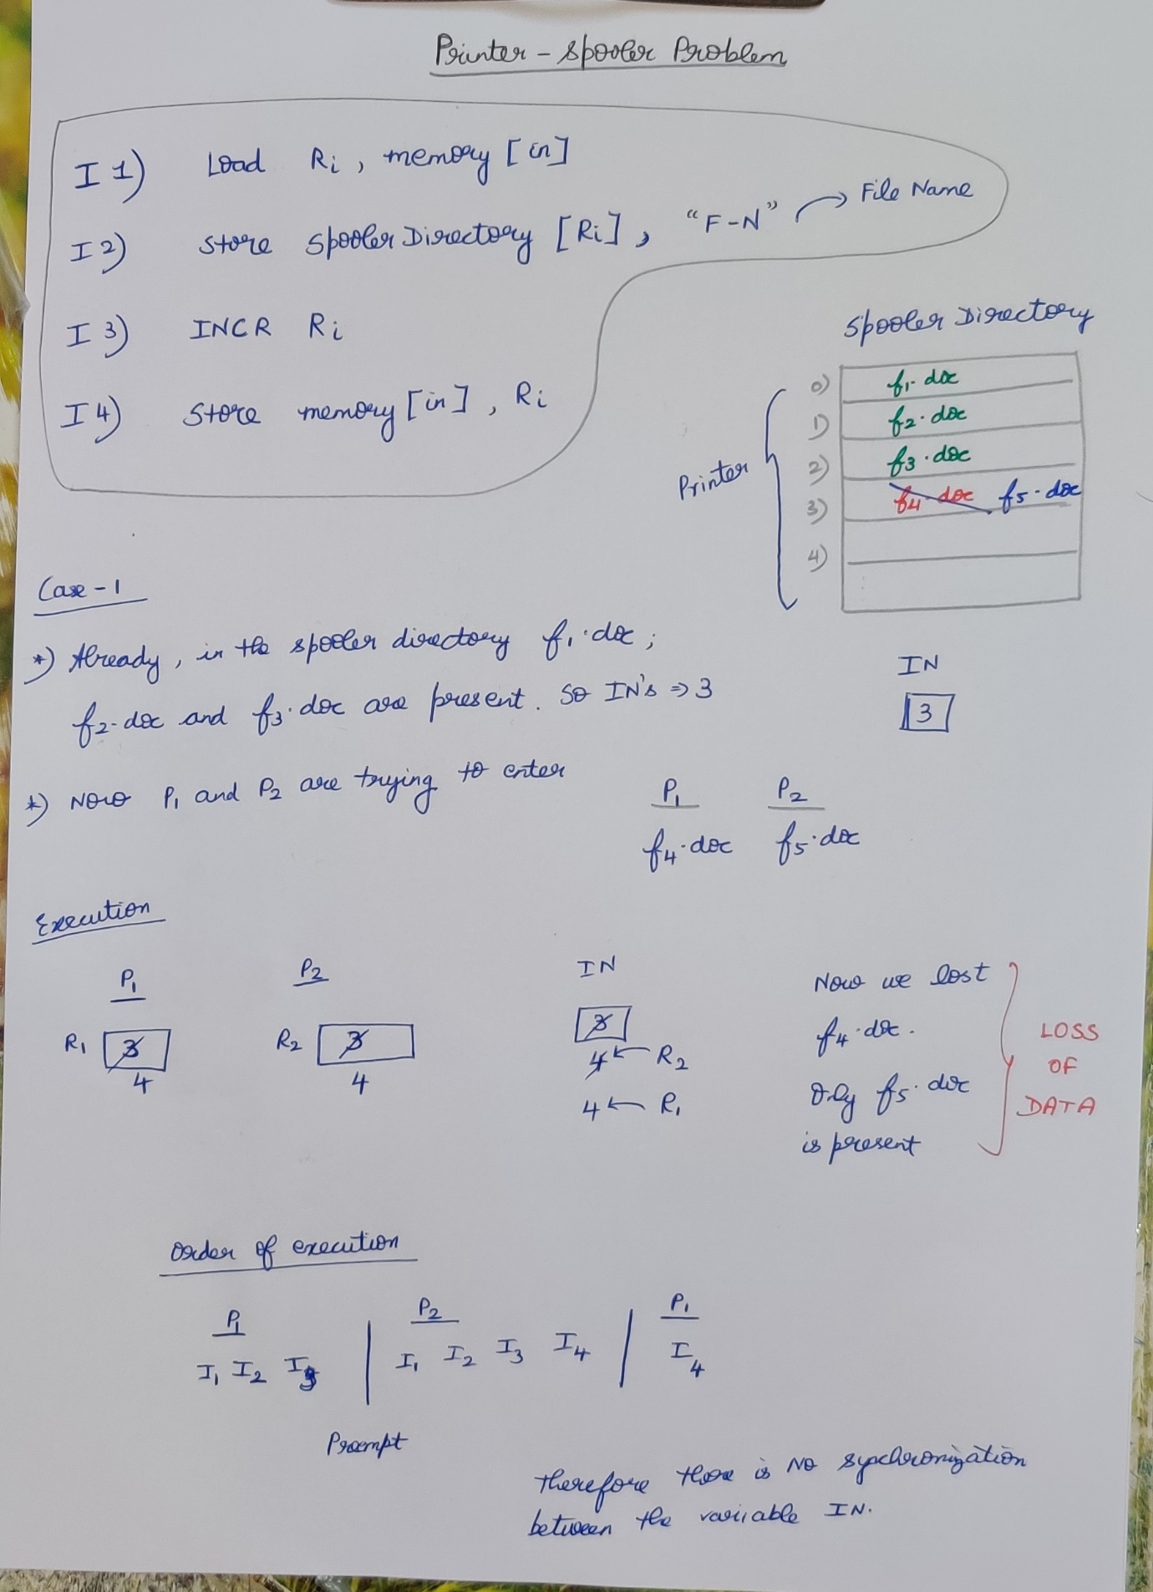

Critical Section 🡪 It is the part of the program where the shared resources are accessed by various process(i.e co-operative process)  
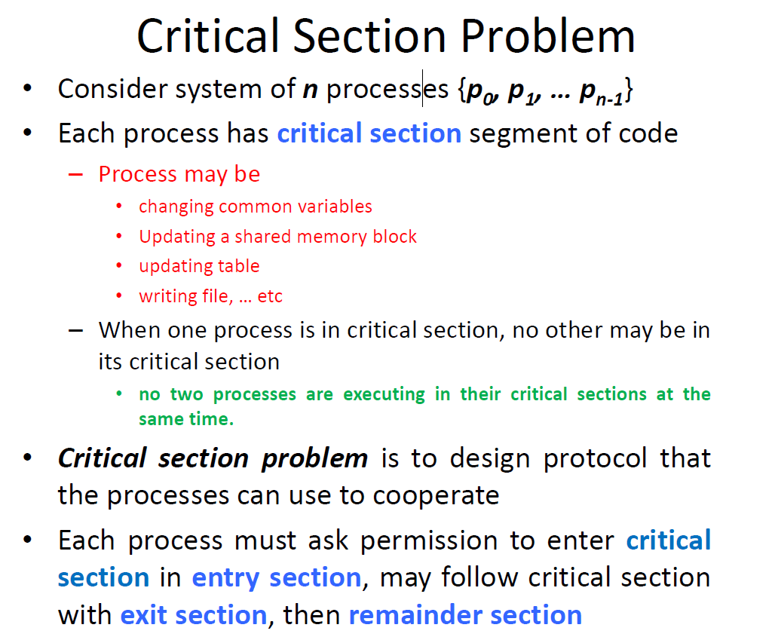

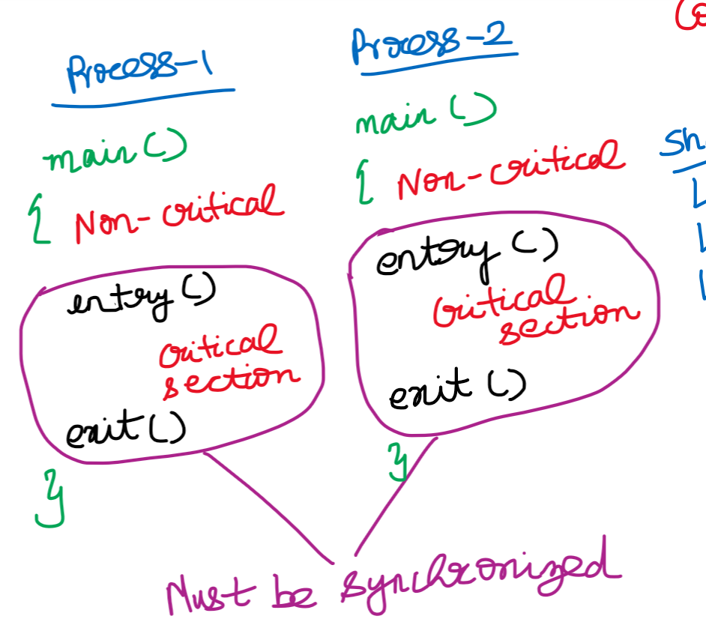



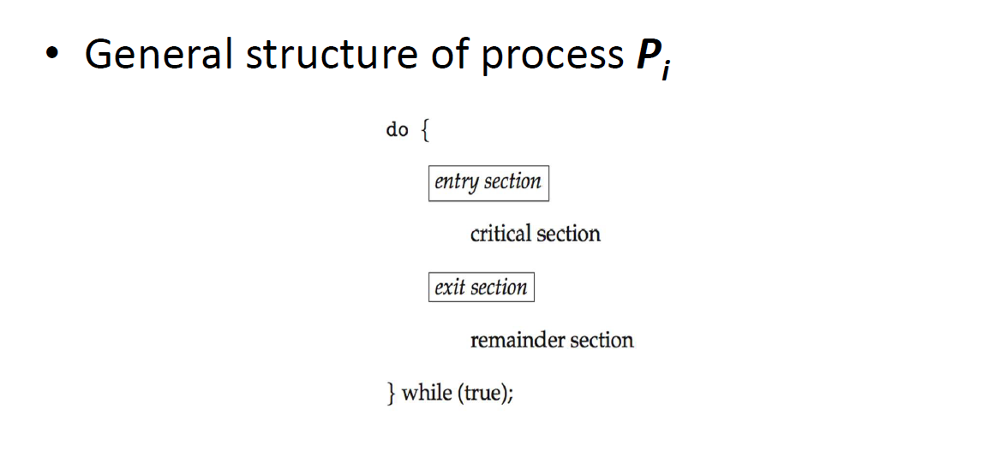

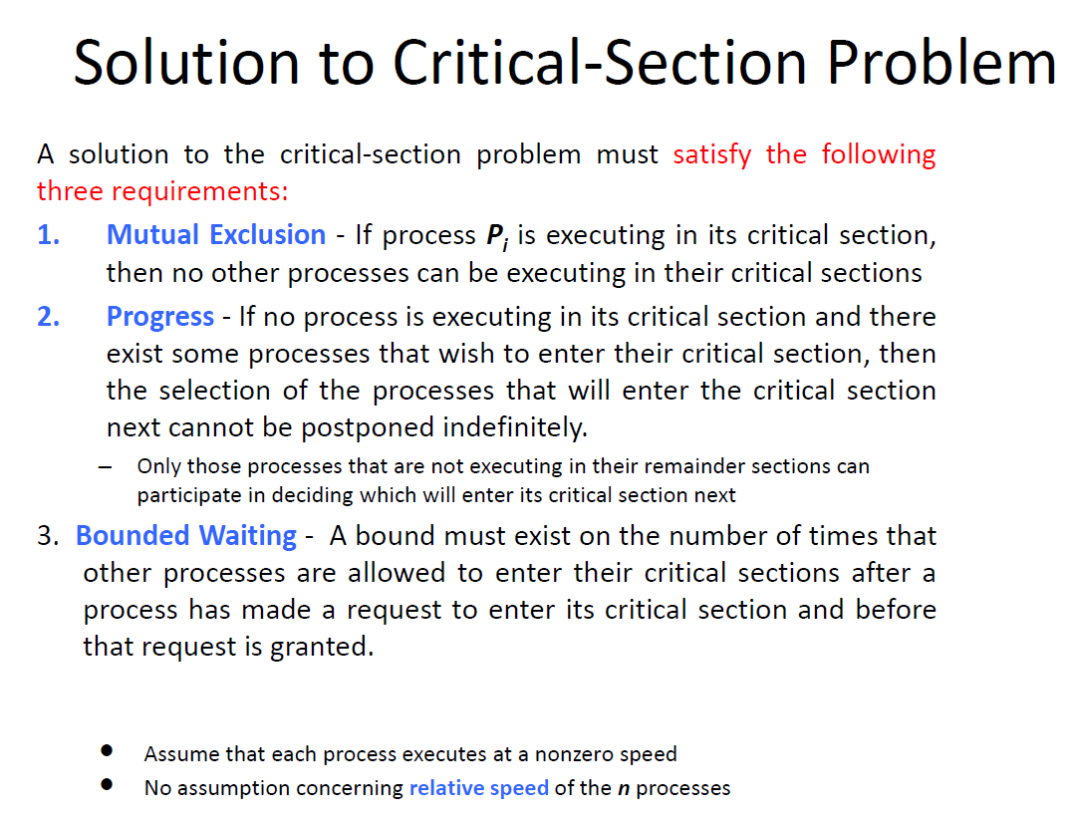  
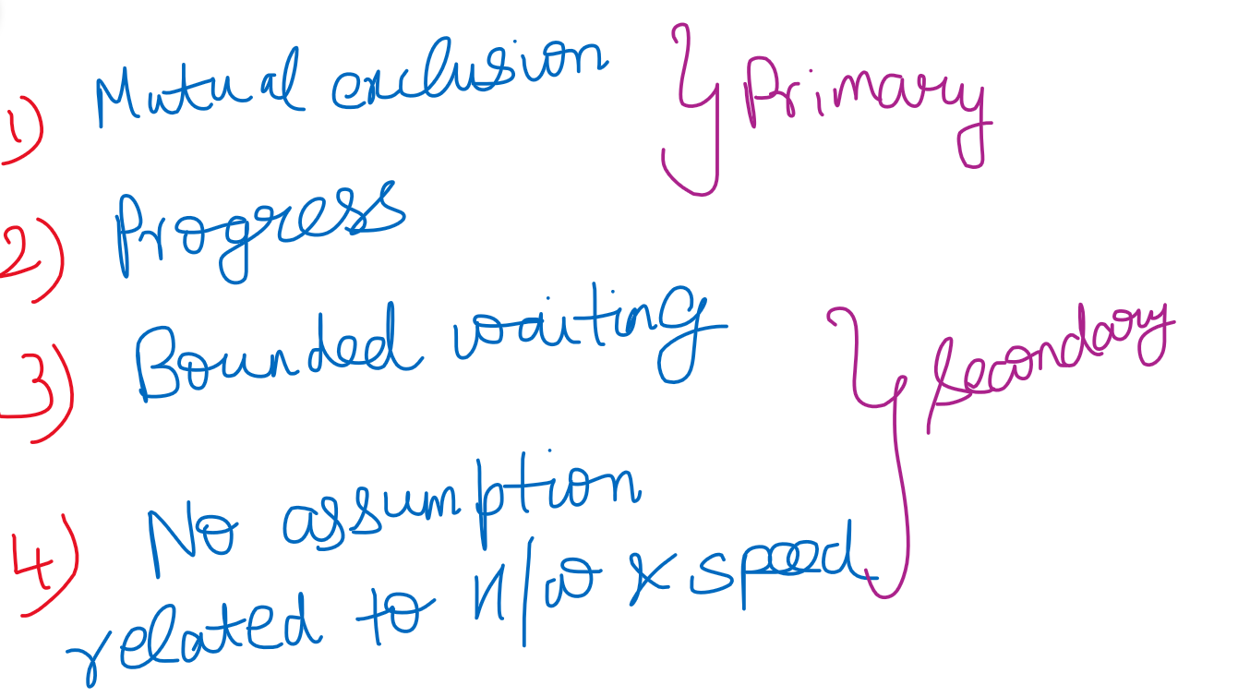

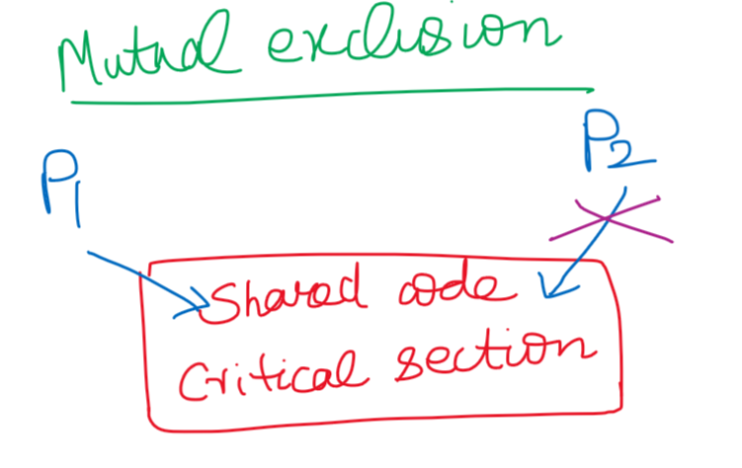

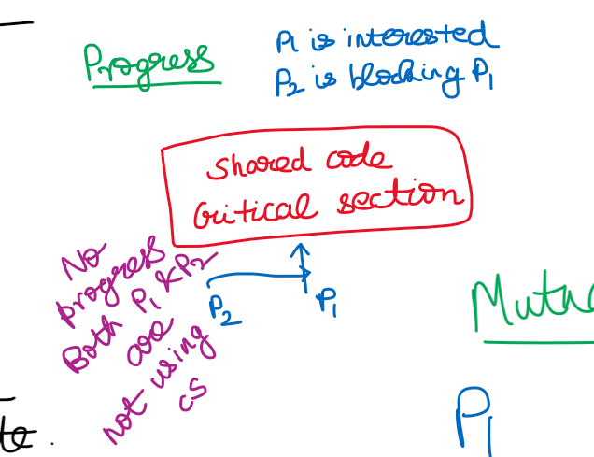



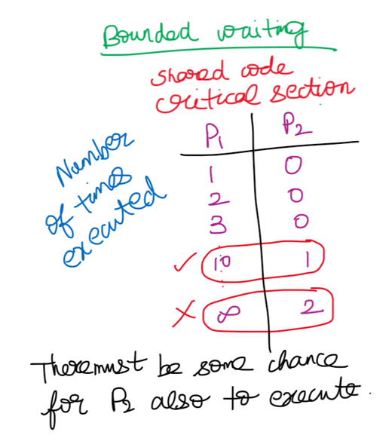

**Peterson’s solution to Producer-Consumer (two -process solution)**

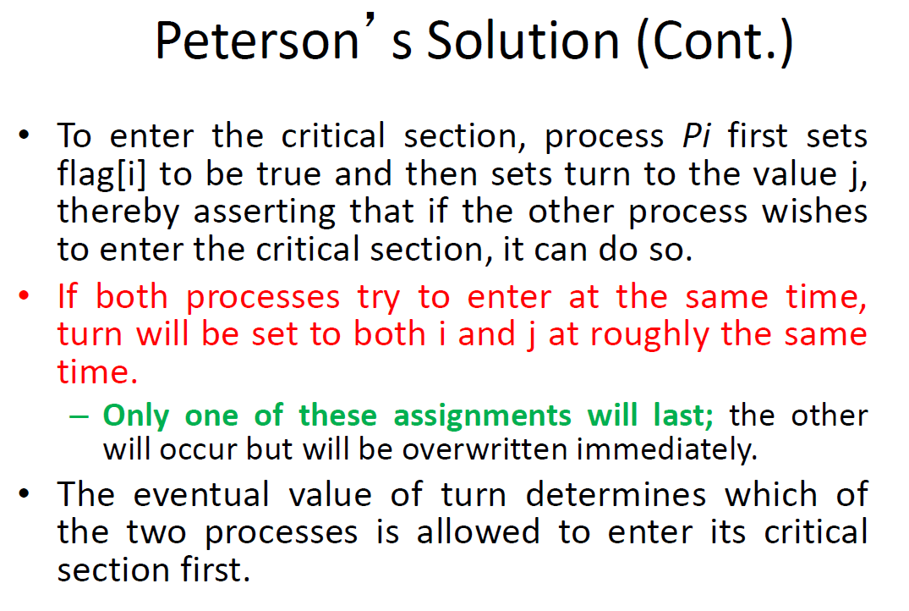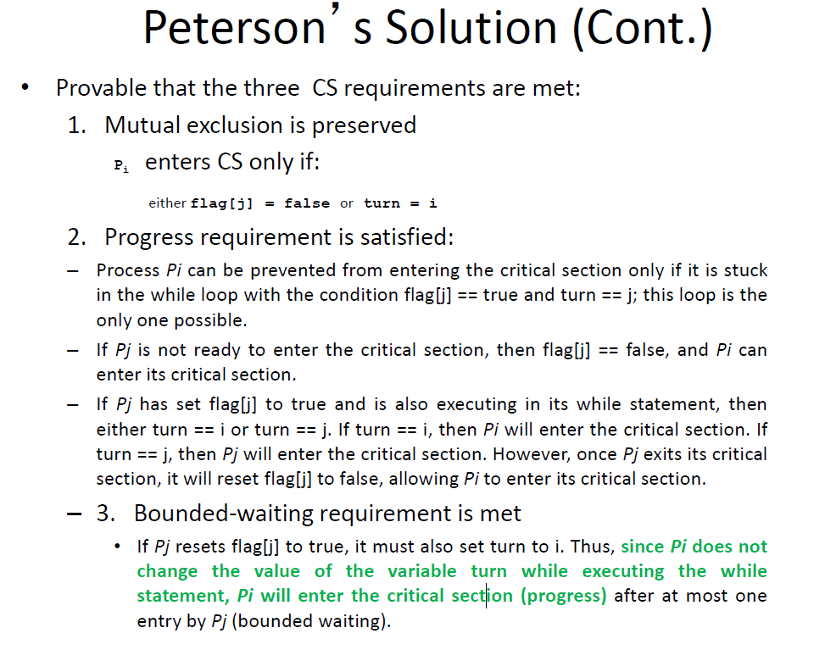

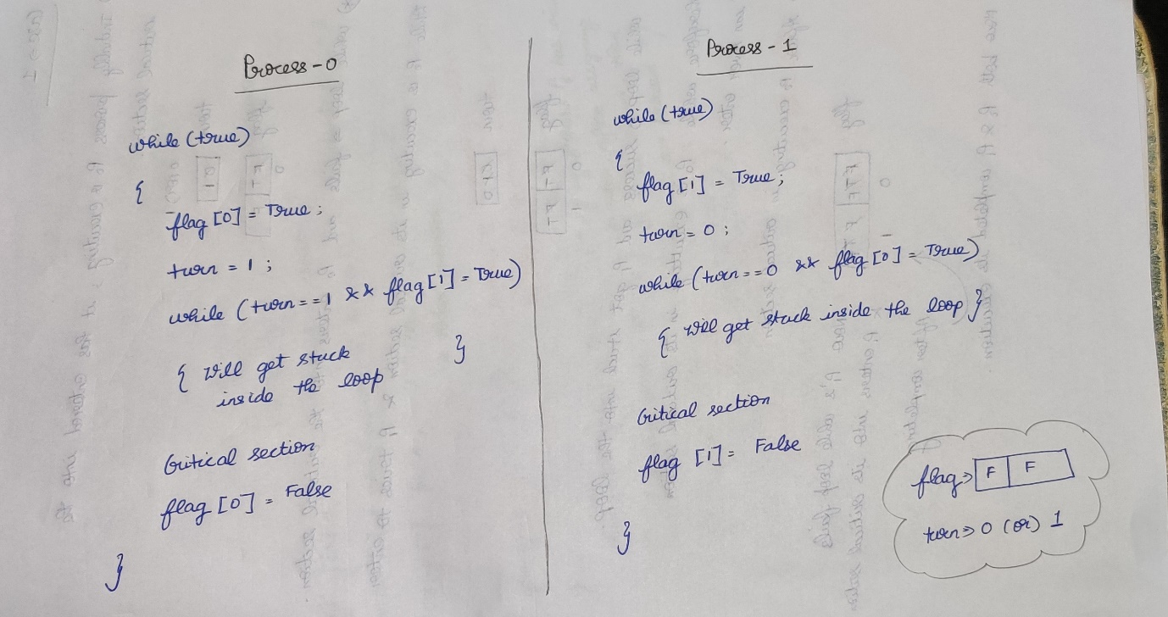

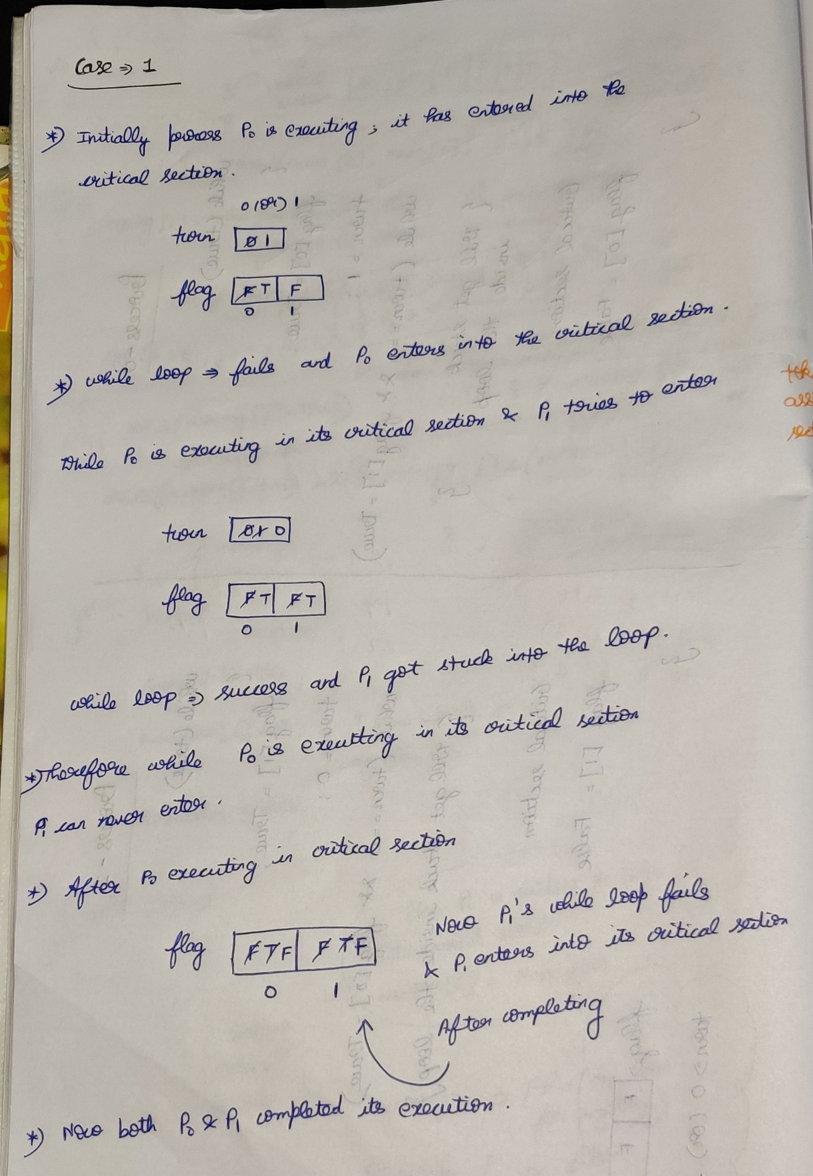

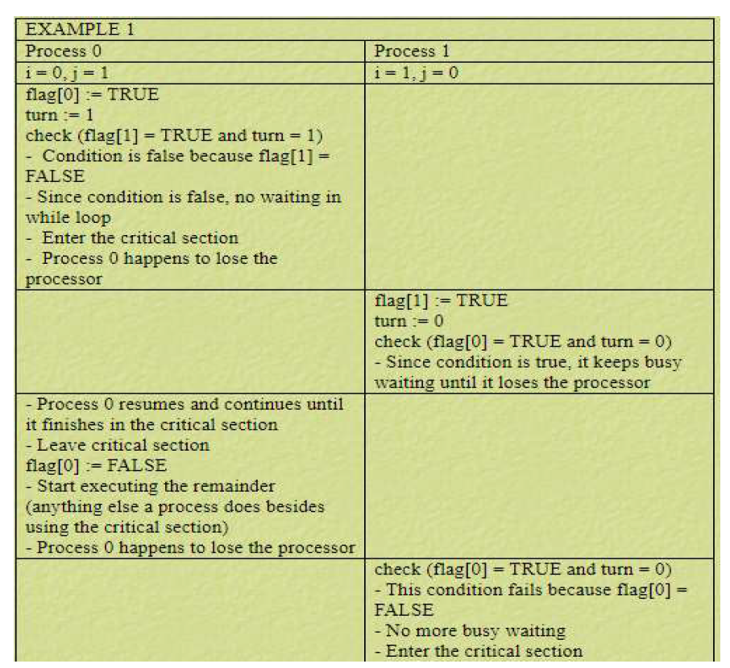

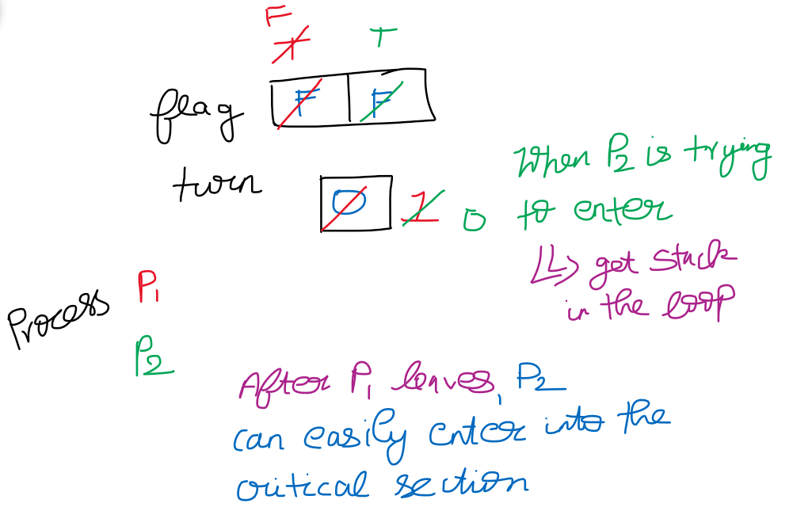

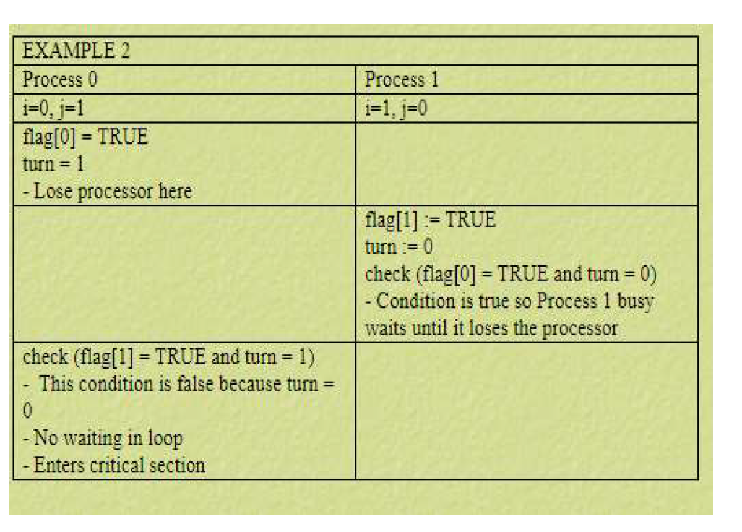

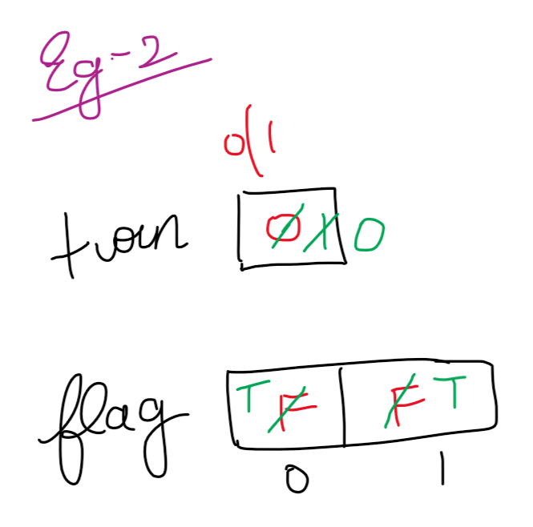

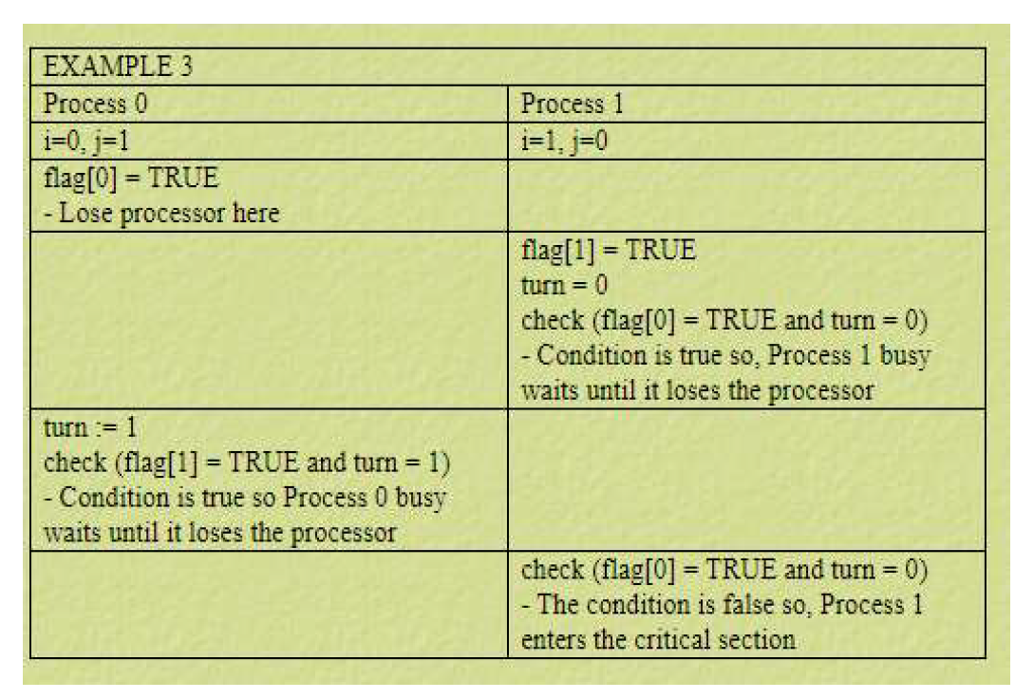

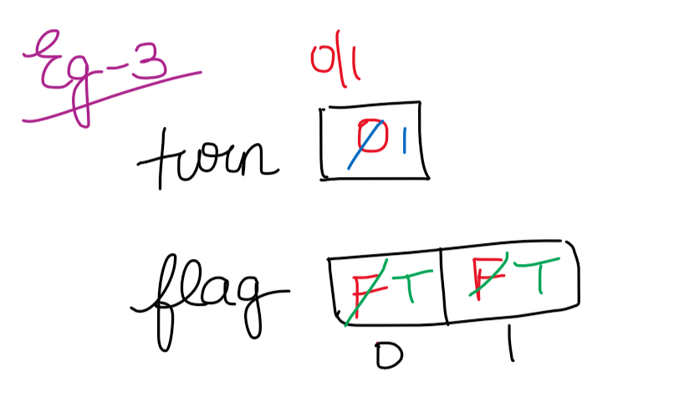

**Lamport’s Bakery Algorithm(N-process solution)**

* Works for the synchronization of an arbitrary set of N co-operative process.
* This algorithm is used when n number of processes wish to enter in their critical section at the same time.
* Before entering into its critical section, that particular process receives a token number. Process having the smallest token number will enter into its critical section.
* If the process Pi and Pj receives the same token number and i<j, then the process Pi will be served first and then process Pj.
* The token numbers are always on the increasing order of enumeration.   
  (i.e 1,2,2,3,4,5,5,5,6,…)
* When a process finishes its execution, its token number is set to 0.

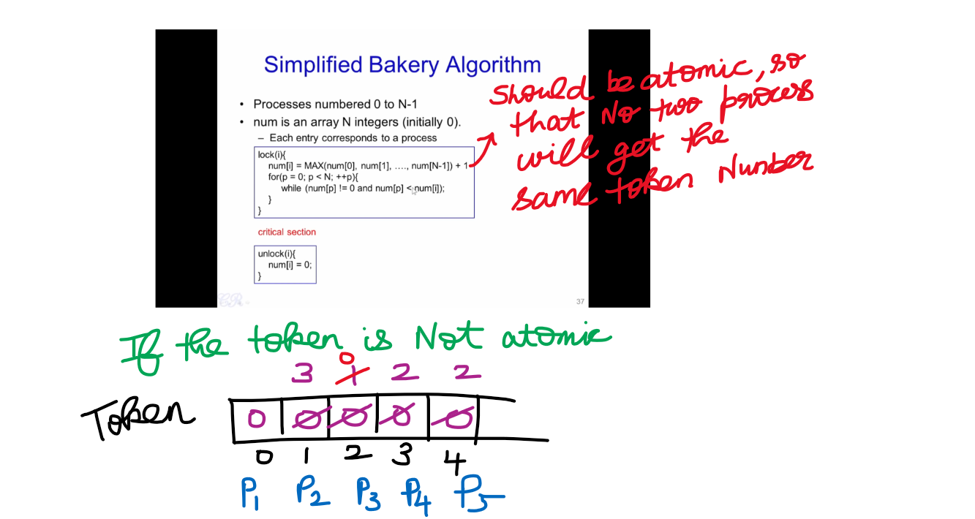

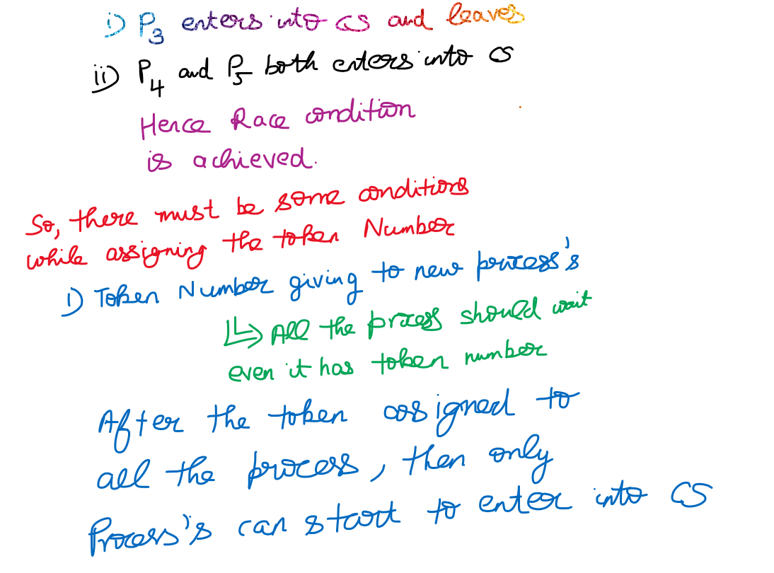

After assigning the atomic condition to token assigning segment

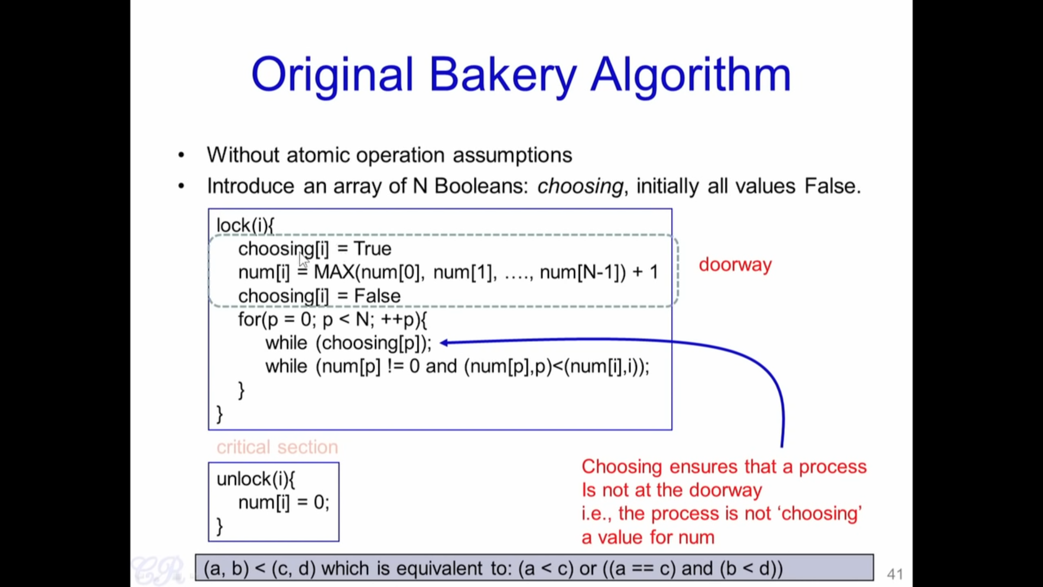

Even though token assigning segment is atomic, there might the possibility of mistakes in token

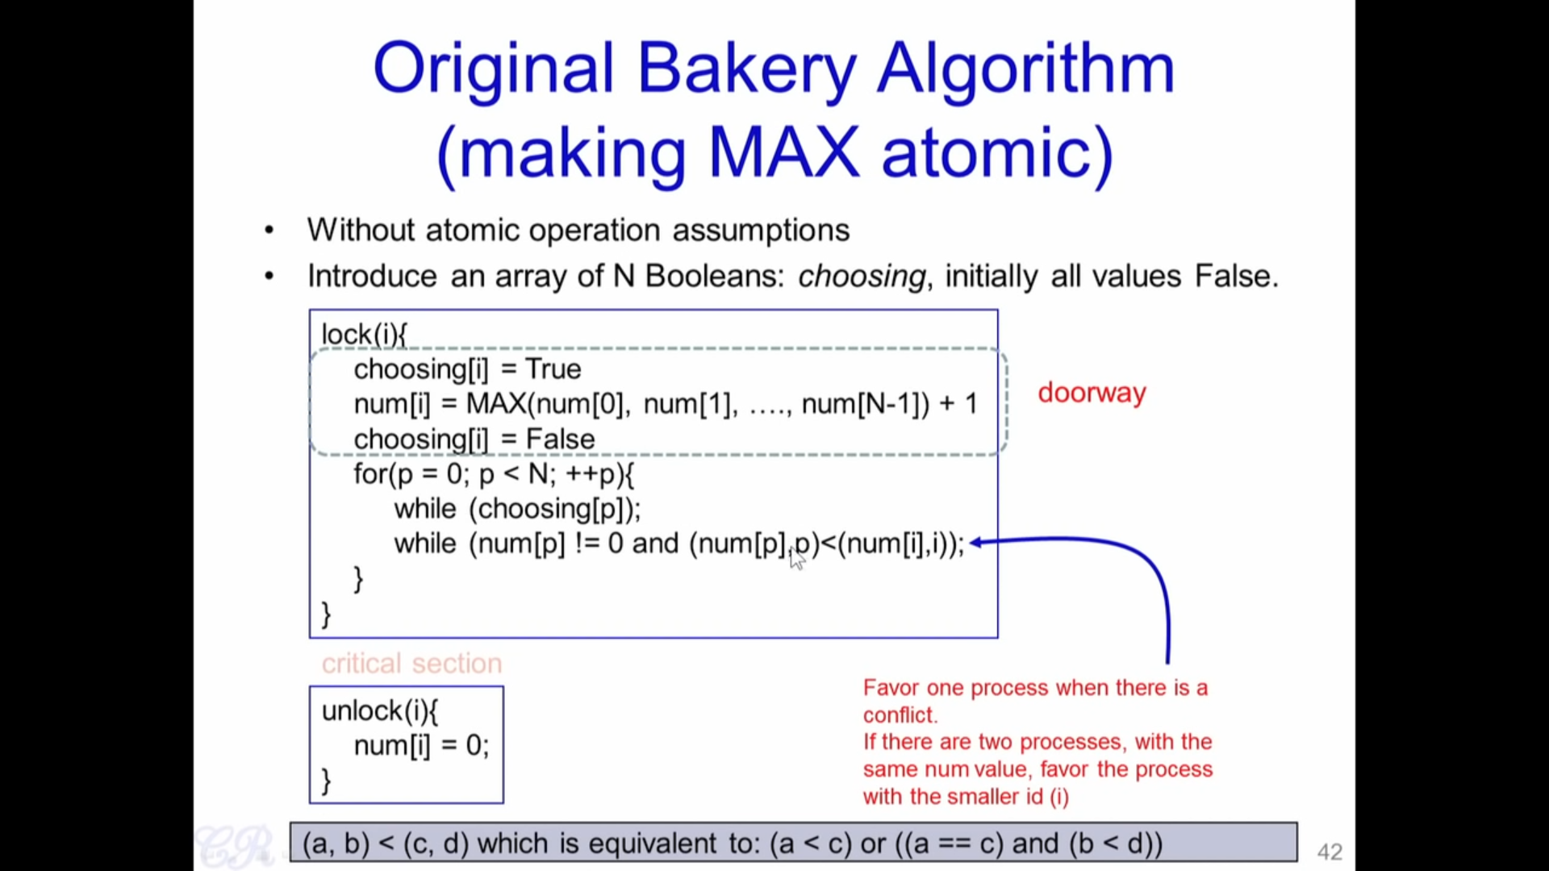

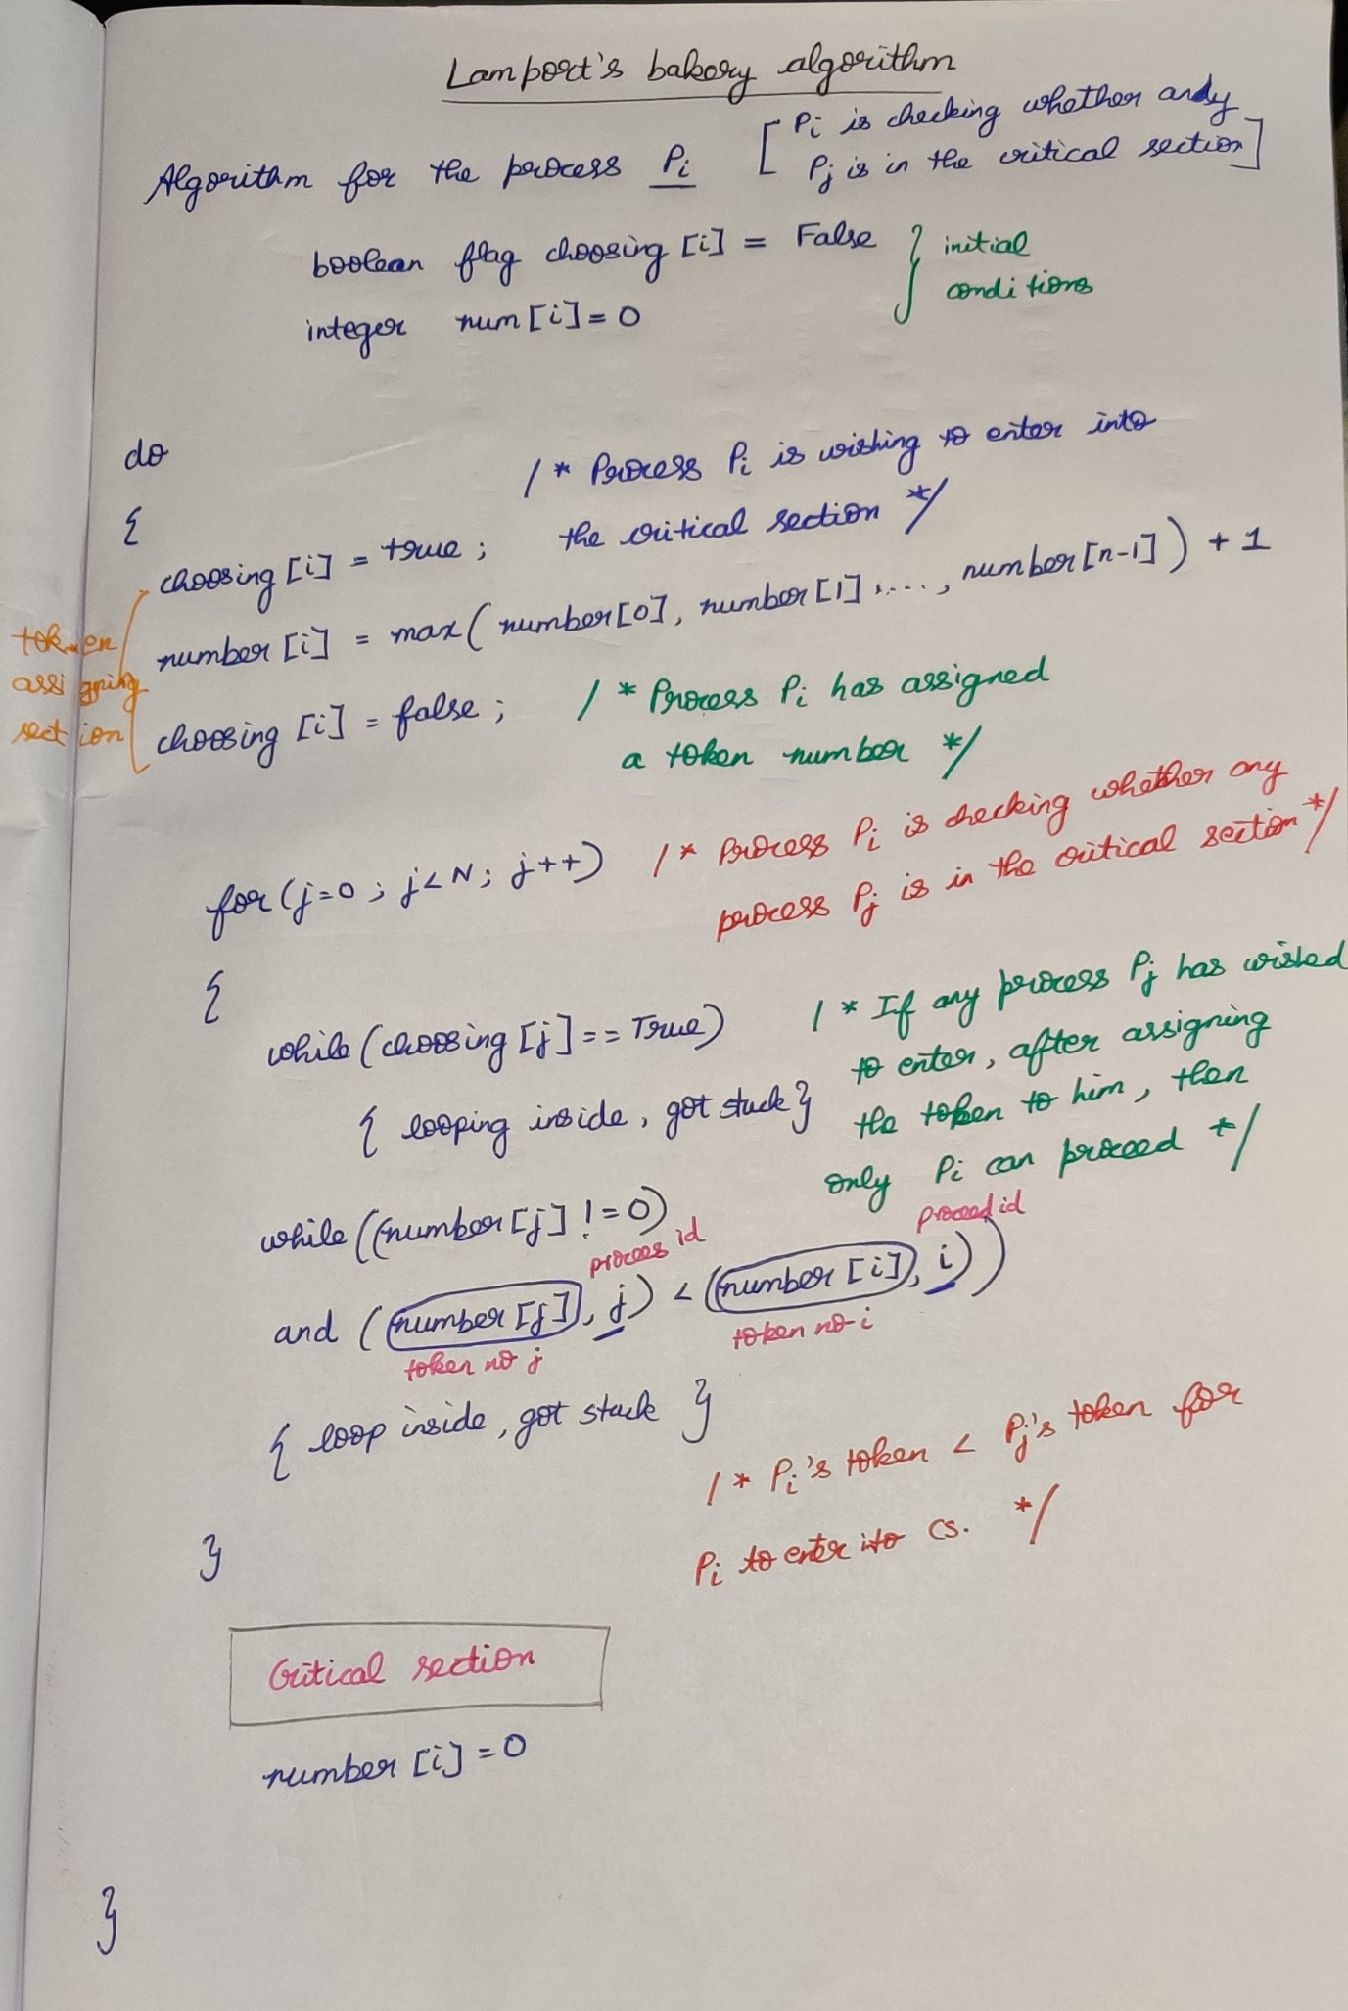

Questions

